Sample Size Determination Using Krejcie and Morgan Table
KENPROAugust 25, 2012
The ever increasing need for a representative statistical sample in empirical research has created the demand for an effective method of determining sample size. To address the existing gap, Krejcie & Morgan (1970) came up with a table for determining sample size for a given population for easy reference.

Table 1: Table for Determining Sample Size for a Finite Population 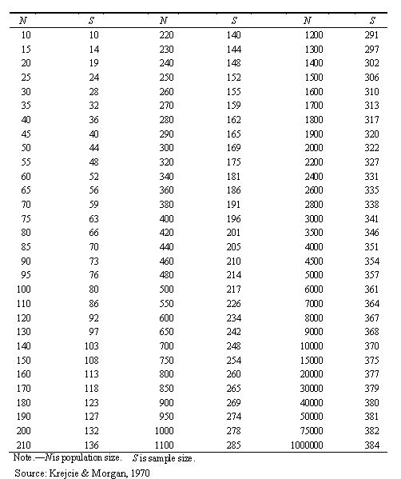
The Table is constructed using the following formula for determining sample size:

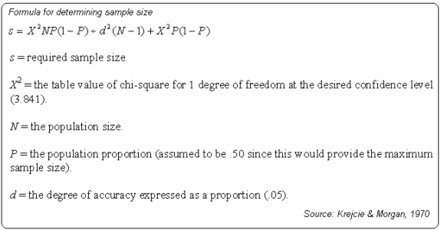

NOTE: There is no need of using the formula since the table of determining sample size has all the provisions you require to arrive at your sample size.

References
Krejcie, R.V., & Morgan, D.W., (1970). Determining Sample Size for Research Activities. Educational and Psychological Measurement.
Small-Sample Techniques (1960). The NEA Research Bulletin, Vol. 38.

